How to Access Student Resources on the Evolve Website
Free study materials accompany many Elsevier textbooks. Locate and get access to these materials using the following steps. You may also notice a link printed inside your textbook. Follow this link to locate and get access to the resources associated with your book.
- Start off by going to http://evolve.elsevier.com/student
- Click on the green Evolve Resources icon
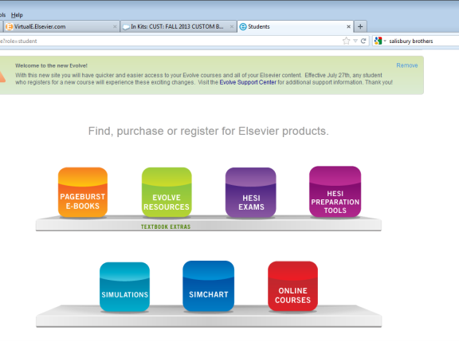

- Search for your textbook by author name or title.
- Click on the link that says “Evolve resources for…….” selecting the appropriate edition of your text.
- You will now be given a choice to “Enroll in your Instructor’s course” or “Register for this Now”
  - If your instructor has provided a course ID, select “Enroll” Your course ID is:
154897_rtuttle3_1002

- Newly revised books (with 2014 copyright date) will ask for an access code. If you purchased a new copy of the book, an access code will be found in the front pages of the book. If you purchase a “used” copy of the book and the access code has been redeemed, you will have the opportunity to purchase access to the student resources.

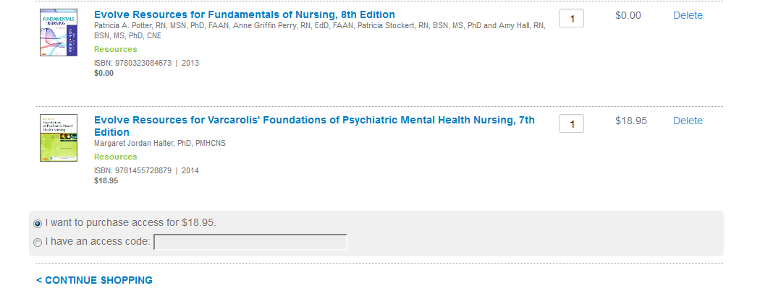
- Enter the access code or select “I want to purchase access” (recent publications only; books published prior to 2013 will not require access code).
- Click “Continue Shopping” to register for additional textbook resources or click on “Redeem/Checkout”

- New users will need to supply name and contact information and accept the User Agreement to proceed. Students with an existing Evolve account will enter their Evolve username & password and accept the User Agreement.
- If you are purchasing access, you will need to provide valid credit card information.
- Click on “Submit”
- You now have access to your study materials. Click the Get Started link to go straight to your My Evolve page and access your resources.
- Technical assistance for Evolve and any Elsevier electronic products is available @ 800 222-9570 or http://evolvesupport.elsevier.com
- Be sure to visit: http://evolve.elsevier.com/studentlife for how-to guides, tools and coupons.

